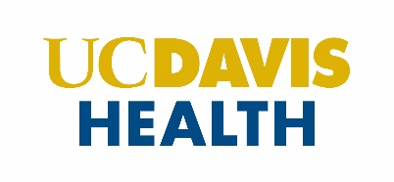

Faculty and Professional Development

ROI Application Program

I agree to mentor ___________________________________ for the FACTS RO1 Application Program.

Please speak to this faculty member’s potential and readiness as a researcher and grant applicant.

If selected, I agree to participate in bimonthly mentoring sessions, mock study section and to personally review my mentees grant.

Signature Date

Print Name

Title

Please upload this completed document with your application.

Mentor Statement of Commitment 2022-2023